Bare handing fauna in emergency situations.

Bare handing wild animals is never recommended. Always use leather gloves. I prefer welding gloves.

Beware: Most critters can shred welding gloves, but they do serve as a nice sacrificial finger if things go wrong.

A rambling list of nuisance wildlife control situations I have handled over the last 30 years.

General rules of communication.

Rule #1. Never ever grab an animal in any manner! Animals in general will treat this as biting on your part. Then respond in kind. Baby animals like kittens can climb up your arm while clawing, chewing and hissing.

Violate rule #1 and you are on your own!

Rule #2 distract the critter and work its tail. For catching opossums and skunks I use the toe of my boot as a distraction; kind of like a little aggressive animal. Than I grab the critter by the tail and keep it swinging until I get it to its destination then I ease it down and let it go. Beware of raccoons! Don’t swing them too close to your leg. They are kind of like monkeys and can hurt you bad.

The skunk holds a shopping mall hostage.
I almost titled it, The crap we call plastic. We have all seen the upside down yogurt cups that are smaller on the top than at the bottom. Turns out that they are perfect skunk traps, Skunks stick there heads in the dang things to get the last taste of yogurt out of the bottom and there head gets stuck in the cup. I have seen many dead skunks with the fatal yogurt cups on their head.
I am not quite sure how the whole mess wound up inside the mall, but it basically shut the mall down. If you want to simulate the event put one of your socks on your cat’s head and let it go. The cat backs up around the room until it bumps into something and backs another direction until it backs into something else and the process repeats itself over and over. It took a couple of hours for the mall management to find me, And another couple hours for me to get there. When I arrived at the shopping mall was pretty much devoid of human life just a poor little skunk walking around backwards bumping into things with a yogurt cup on its head.
I donned my welding gloves and approached my subject. I carefully folded her tail around her backside with my right hand and supported her chest with my left hand then carried her out of the mall and placed her in the box of my pickup truck. I opened a can of tuna and yanked the yogurt cup off her head and slid the open can of tuna in front of her. She ate most of the can so then I gave her all the water she could drink. I put her in the cab of the pickup and she crawled under the seat and went to sleep. I drove her off to the edge of the 960-acre playground and let her go.

The bat in the toilet.

I got a call one-day from a panicky woman about a bat in her toilet. I could hardly understand her on the telephone she was so scared, I finally made out her address and drove over there. I assumed that the bat was dead in her toilet, What actually happened on that hot July day was even a bit better. The bat was actually hanging in the inside of the toilet seat when the rather large lady sat on his toes. So as natural the bat just climbed his way up to the top of the obstruction and flew away, From his perspective.

What the lady experienced is beyond my comprehension. The bat woke up; Crawled around on her backside until he found a crevasse then up between her thighs then took off and flew around the room.

Gordies woodchuck removal tonic.

Gordie is a local farmer that despises woodchucks; His claim is that each woodchuck eats up $120.00 worth of farmer’s soybeans each year. In the state of Michigan its against the law to put stuff like poison gas down a critter hole because there might be a protected critter down the hole and not your intended victim. The trick is getting the varmint out of the hole so you can ether let it go or finish it off.

Gordie discovered his woodchuck removal tonic by accident; He is an older fella and kind of fat and prone to laziness. He got in the habit of urinating in a gallon jug while drinking beer in the barn at night; He also drinks lots of beer. One hot summer day after the jug had festered in the barn for a while It really stunk badly! Gordie dumped the contents of the jug down the nearest woodchuck hole and shoveled some dirt into the hole. Within one minute the woodchuck exploded out of the hole and started rolling around in the grass like it was on fire. Gordie grabbed the shotgun out of the barn and dispatched the chuck. Its now become a yearly tradition Gordie makes the stuff in 55 gallon drums and each year he loads the drum in the back of the old pickup truck he then cruses the edges of his fields looking for holes.

The rabbit hunting incident.

My cousin and I where rabbit hunting on the back 40 of granddads farm when we where around 12 or 13 years old. We had circled the big brush pile several times but never got a clean shot, The rabbits would dive into the brush pile as soon as you spotted them. Paul suggested that he climb up on the brush pile and jump around to scare out the rabbits and I would stand below and try to get a clean shot. Sounded like a plan to me. After a few minutes of jumping around on top of the brush pile Paul came tumbling off screaming and crying. I am not a superstitious guy but from my perspective it looked like Paul had picked up a demon of some kind on top of that brush pile. He was moving around in an odd manner and making all kinds of strange noises? He was pointing to the inside of his left thigh; there was some kind of strange lump in his pants moving around making a kind of growling noise. I raised my shotgun up high and drove the but end of it into the lump, The lump quickly moved out of the way like it seen it coming. It moved on to Paul’s backside. After about a half dozen or so furious jabs with the but of my shotgun the lump quit moving and Paul’s voice went up several octaves. Paul dropped his pants and the dead mink came tumbling out.
He really wasn’t all that bad off, About 45 bites on his lower extremities and several large bruises.

We got $17.00 for the mink pelt.

The other rabbit hunting incident.

We have some large field stone piles in this part of Michigan thanks to the glaciers that covered the area a couple thousand years ago. The local farmers just considered them a hazard to there farm implements and piled them up in the back 40. Some of the larger piles where full of rabbits but once again many times the rabbits would dive off into the rock pile before you could get off a shot. Paul and I formulated a plan that was sure to get the rabbits moving out of the rock pile. Armed with our trusty shotguns and 5 gallons of gasoline plus 5 gallons of kerosene we headed off to the rock pile. After dousing the 30-foot by 30-foot pile with our flammable mixture we climbed off and debated weather we should light it right away or let it soak in for a while. I lit a whole pack of matches and flung it towards the pile, The matches didn’t even get near the rock pile. A baby Hiroshima erupted and I can say for a fact that we left no stone unturned that day.
After we picked our self’s up off the ground and stomped out the burning grass, We couldn’t help but notice the trail of vehicles coming our direction. We didn’t get one rabbit, We did feel granddads belt on or backsides however.

Eastern Milk snakes. (lampropeltis triangulum triangulum)

I get lots of calls about these guys, Pretty harmless snake that eats lots of rodents.
They get killed a lot by ignorant people. Milk snakes mimic rattle snakes they coil, boil and strike a lot. There tail rattling in dry leaves and brush sounds just like a rattlesnake to the untrained ear. So Many folks just blast them with a shotgun? I like just reaching down and grabbing them with my bare hand while letting them gum my hand or arm to death. The customer usually has an adverse reaction to this method of capture but I find it’s the gentlest way.

There is a water moccasin in my pond and it bit my children.

Northern water snakes (Nerodia sipedon sipedon) a medium to large (2-6 feet) dark colored snake seen in or near water. I got a panicky call about these guys one time that was a rather large specimen a little over five feet long and black like coal. It had taken up residence on a private pond and the woman’s children thought that it was good fun to poke it with sticks, It bit both of them somehow? Though they are not poisonous they have hundreds of small teeth and the bitten area swells up and turns red for several hours.
I know of areas that use to support hundreds of northern water snakes that now have none. Developers have built large subdivisions on the edge of their habitat and the new villain’s have virtually erased the entire population. Sad and ignorant humans cause more damage than they will ever admit to.

George and the bear chase.

George was fanatical about dirt bike riding in the northern piney woods. He would go all weekend every weekend or at least as much as his wife would permit. He was riding in a secluded area one day when he spotted a black bear minding its own business. George made a beeline for the poor bear with the dirt bike at full throttle, George claims that the bear was doing a pretty good job of staying ahead of him, It was clearing bushes and making turns that the dirt bike could not match. After about a mile the bear got tired of the chase, He stopped turned around and stood up on his hind legs. George claims that at that point turning the dirt bike around and heading the other direction seemed to take forever.

Ron and the bear cub dilemma.

Ron was traveling on the interstate when he saw what he thought was an accident. Several cars where pulled over along side the highway and a group of people had gathered. Ron pulled over to see if he could help out in some way. What he found was that a sow bear and one of her cubs had been hit by a car and killed. The remaining cub was uninjured and clinging to momma. No body was quite sure what to do but the little bear tugged on Ron’s heartstrings.
A local dairy farmer was one of the people in the crowd and he suggested that he could at least provide temporary food and shelter until a long-term answer could be found. He and Ron exchanged phone numbers they lassoed the little bear and secured it in the back of the farmers pickup truck and all where on there way again. A couple hours later Ron got a phone call from the dairy farmer, His cows where having a very adverse reaction to the little bears presence in the barn and he was afraid that it would effect his milk production. Was there any chance that Ron could provide the little bear temporary shelter? Ron was elated, At first. The first night was pure hell in his opinion, He put the little bear in the back room with a blanket in a box. It made for a very long night, In Ron’s own words it sounded like there where 3 little bears throwing a fit in the back room the only answer was to put the bear’s blanket in the bedroom next to the bed, Then they both finally got some sleep.
Ron and the bear where inseparable every where that Ron went the bear followed, The bear rode in the seat of Ron’s pickup like a large child it wore a seat belt and sat in the seat. They where spotted several times at a local bar eating burgers and drinking beer. Ron was the butt of many jokes about the bear being a replacement for his ex-wife.
Some nine or ten months passed, one day a young attractive lady DNR officer showed up at Ron’s door demanding the bear all the time talking to him like he was an idiot for having the bear in the first place.
Ron tried to explain the situation several times to no avail.
She had a pickup truck with a large cage in the back to transport the bear with. She coaxed the bear to the back of the truck opened the tailgate and the cage then bent down and picked up the bear and attempted to lift the bear up and stuff it into the cage.
In Ron’s own words total chaos broke out, In short order the girls cloths where stripped off and she was left standing in his driveway attempting to tie her panties back together. The little bear was standing next to him rocking back and forth on his front paws. You must remember that that bear had never seen a leash or a cage with the exception of the day that it came to live with humans.
Ron offered Band-Aid’s and iodine but Ms. DNR refused she growled at him while gathering up he tattered cloths that her supervisor was coming and there was going to be hell to pay, Then drove off.
Her supervisor arrived the next day he was a large older man in his late fifties he had a calm gentle demeanor and a quiet voice that you had to listen to in order to hear. He and Ron talked for several minutes and Ron explained the whole situation including the fact that the bear was eating him out of house and home. The supervisor coaxed the bear into the front seat of his car, Put on the bears seat belt and they drove off.

Seventeen raccoons in 1 attic.

I got a phone call from a woman about a raccoon problem; She was a well to do woman that lives in an upscale area of our town. It may sound like a crazy thing to say but the first thing I smelled when I walked in the door was raccoon. The first thing that she showed me was a large brown stain over her dining room table it was about three feet across and sagging like an upside down blister. She showed me the attic access to that part of the house, I got my ladder and donned my headlamp and went up to see what was going on. There was movement everywhere and little eyes peering out at me from every nook and cranny. The thought of being in a confined space with that many raccoons made my adrenaline flow a bit. The depressed area in her ceiling was a raccoon latrine they all relived them self in the same spot like cats do. A quick survey revealed that all of the insulation was trashed and much of the wiring was chewed. I quickly got out of that attic. A look out side showed me that the entry point was an aluminum soffet that was out of place, The raccoons where climbing up the corner of the masonry and into the soffet.
The patio also had four large bowels of dog food; I am talking big bowels like St. Bernard size.
When I asked her where the dogs where she told me that the food was for the raccoons, they where all God’s creatures and she liked to watch them?
I gave her the long lecture about attracting her own nuisances and an estimate.
Her and her son removed all traces of the feeding station, and I got to work.
I was live trapping coons there for a week, Trap and release is not always an option. The world as portrayed by the made for TV show in the 1970's called Wild Kingdom does not apply. Every raccoon I let go into a wild area has at least three other raccoons wondering where that new raccoon is going to eat. The fighting can last all night and somebody always loses. As you can guess I had to euthanasize all the raccoons.

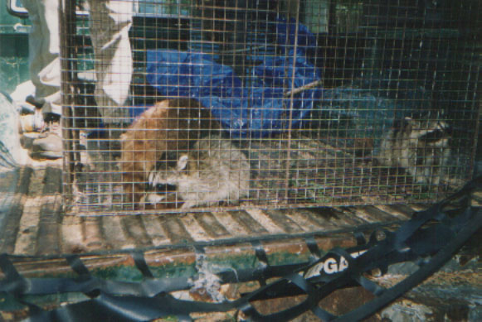

The raccoon in the parked car.

Raccoons love dumpsters, In fact many are killed each year because they get into dumpsters and cannot get out. If you see one in a dumpster and want to help it get out put a piece of lumber in the dumpster with one end on the top of the dumpster and the other end in the bottom of the dumpster, The raccoon will climb out on its own. Raccoons are much stronger that they look, If the business end gets a hold of you they tend to chew on you for a while, and it hurts. An incident prior to this cost me better than $400.00 for the Rabies shots.

Back to the story. On August 18th 2004 the raccoon was Dumpster diving when the compactor truck showed up, With no way out the raccoon was dumped into the truck along with the trash. He was seen surfing on the compactor truck by many people eating lunch at Morley Plaza in Saginaw Michigan on southbound Washington Ave where he bailed, Crashing through the back of Mr. Bankers car window sliding between the two front seats and coming to rest between Mr. Bankers feet.
He hid under the seat for about an hour while a crowd built near the car.

That’s when they called me, I had to get the little bugger by the tail because the other end was kind of mad.
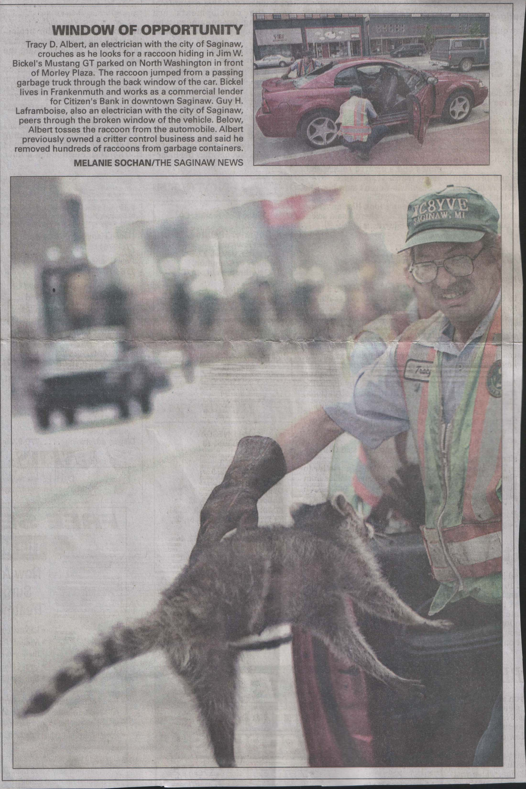

Photo By: Melanie Sochan at the Saginaw news.

I had Several fears going on at once here, First was the business end of the raccoon, 2nd I had never done this in front of such a large crowd, 3rd News 5 and the Saginaw News was there.

What if I got the little bugger out and he ran out in traffic in front of everyone?
You can tell by the look on my face, who had my attention!
Things worked out, I managed to chase the raccoon toward Morley Plaza, and he spent the evening eating ribs out of the trash and watching the symphony!
I made the Front page of the Saginaw News. Was on News 5, Inside edition, and seen on a European news channel in Spain. The City gave me a pretty piece of paper for helping a citizen in distress. All over a little OLE Raccoon?

So much more to go.

